
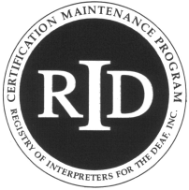
Alabama Institute For Deaf and Blind
Huntsville Regional Center

Program Evaluation Form

Activity Title: Music in Motion

Presenter: Stacie Yarbrough

Activity Date(s): August 28, 2010

Read each statement carefully and select the number that most accurately describes your feelings.

Disagree Agree
1 | 2 | 3 | 4 | 5 | This activity had clearly stated objectives
1 | 2 | 3 | 4 | 5 | My instructor(s) communicated a clear understanding of course content
1 | 2 | 3 | 4 | 5 | This activity built understanding.
1 | 2 | 3 | 4 | 5 | The content of this activity was described adequately in advance publicity.
1 | 2 | 3 | 4 | 5 | The instructional level of this activity was consistent with my expectations.
1 | 2 | 3 | 4 | 5 | The organization of this activity allowed for maximum learning.
1 | 2 | 3 | 4 | 5 | Audiovisual and supplementary study materials were an asset to this activity.
1 | 2 | 3 | 4 | 5 | This activity will contribute to my professional growth.
1 | 2 | 3 | 4 | 5 | This activity will motivate me to seek further continuing education.
1 | 2 | 3 | 4 | 5 | Overall, this activity was outstanding.

Comments: ____________________________________________________________________________________________________________________________________________________________________________________________________________________________________________________________________________________________________________________________________________________________________________________________________________________________________________________________________________________________________________________________________________________________________________________________________________

